
An-Najah National University
2026
Artificial Intelligence-Based Intrusion Detection for Enhancing Wireless Network Security
Dr. Jehad Hammare.
By: Shahd Radwan, Taqwa Qadah.

Table of Contents
Abstract
Introduction
Problem Statement
Objectives
Literature Review
Background
6.1 Wireless Network Security
6.2 Intrusion Detection Systems (IDS)
6.3 Artificial Intelligence and Machine Learning
Types of Attacks
Types of Intrusion Detection Systems
Proposed System
System Design
Methodology
Implementation
Results and Evaluation
Comparison with Traditional Methods
Advantages
Challenges and Limitations
Future Work
Conclusion
References

Abstract
Wireless networks are an essential part of modern communication systems, but their open and distributed nature makes them highly vulnerable to cyber-attacks. Traditional intrusion detection systems (IDS) mainly depend on signature-based techniques, which are effective for known threats but weak against unknown or zero-day attacks and often generate high false alarm rates.
This research proposes an Artificial Intelligence (AI)-based IDS for wireless networks using the Random Forest algorithm as the core classification model. The proposed system analyzes network traffic features and detects abnormal patterns that may indicate malicious activity. By adopting an anomaly-based approach, the system is designed to recognize both known and previously unseen attacks more effectively than conventional signature-based systems.
The main objective of the proposed model is to improve detection accuracy, reduce false positives, and enhance the security and reliability of wireless communications. The expected outcome is that the Random Forest-based IDS will outperform traditional security mechanisms in identifying suspicious traffic within wireless environments.

Introduction
Wireless networks have become a fundamental part of modern communication because they provide mobility, flexibility, and cost-effective deployment in homes, businesses, and public spaces. Despite these advantages, wireless communication remains highly exposed to security threats because data is transmitted through the air and can be intercepted or disrupted more easily than in wired environments.
As the number of connected devices continues to increase, wireless networks are increasingly targeted by attacks such as Denial of Service (DoS), eavesdropping, spoofing, and Man-in-the-Middle (MITM) attacks. These threats can compromise confidentiality, integrity, and availability, resulting in service disruption, financial loss, and exposure of sensitive information.
Traditional protection methods such as firewalls and signature-based IDS are no longer sufficient on their own because they depend on predefined rules and known attack signatures. To overcome these limitations, researchers have turned to Artificial Intelligence and Machine Learning techniques that can learn network behavior, recognize abnormal traffic patterns, and support real-time intrusion detection. This study focuses on using Random Forest to enhance intrusion detection in wireless networks.

Problem Statement
Wireless networks face major security challenges due to their broadcast nature, dynamic topology, and limited monitoring visibility. These characteristics make them vulnerable to attacks such as eavesdropping, DoS, and MITM, which threaten the confidentiality, integrity, and availability of transmitted data.
Conventional security solutions struggle to protect wireless environments effectively because they mainly rely on known attack signatures and cannot adapt well to new or evolving threats. As a result, there is a need for an anomaly-based IDS that can learn from traffic behavior and detect both known and unknown attacks.
However, designing an efficient AI-based IDS for wireless networks remains challenging because of traffic variability, changing attack patterns, and the need for accurate detection with a low false alarm rate. This research addresses that gap by proposing a Random Forest-based IDS tailored for wireless network traffic analysis.

Objectives
The main objectives of this research are:
1. To develop an AI-based IDS for wireless networks using the Random Forest algorithm.
2. To improve the detection of both known and unknown attacks compared with traditional signature-based IDS methods.
3. To analyze wireless network traffic and identify abnormal patterns that indicate potential intrusions.
4. To reduce false positives and false negatives in the intrusion detection process.
5. To evaluate the effectiveness of the proposed system using standard performance metrics.

Literature Review
Intrusion Detection Systems (IDS) play an important role in protecting communication networks from malicious activities. Traditional IDS were originally designed for wired environments, where network behavior is relatively stable and easier to monitor. However, the rapid expansion of wireless networks has introduced new security challenges because of their open and dynamic operation.
Several studies have examined the use of Artificial Intelligence and Machine Learning to improve intrusion detection performance. Research in wireless and sensor-based environments shows that intelligent detection mechanisms can provide better adaptability and stronger performance than purely signature-based solutions. Lightweight and efficient techniques are particularly important in environments with limited resources and high traffic variability.
Previous work also highlights the difficulty of detecting unknown attacks using traditional approaches. Machine learning-based IDS solutions address this limitation by learning normal and malicious traffic patterns from data. Among the available algorithms, Random Forest is frequently recognized for its strong classification performance, resistance to overfitting, and ability to work well with complex, high-dimensional feature sets. Based on these advantages, this research adopts Random Forest as the core detection model for wireless network intrusion detection.

Background

6.1 Wireless Network Security
Wireless network security focuses on protecting data and services transmitted over the air. Because wireless communication uses a shared broadcast medium, any device within range may attempt to capture or interfere with traffic. This makes wireless systems more vulnerable to unauthorized access, eavesdropping, and service disruption than wired networks.
The main security goals of wireless networks are commonly explained through the CIA triad. Confidentiality ensures that only authorized users can access sensitive information. Integrity ensures that transmitted data is not altered without permission. Availability guarantees that network resources remain accessible to legitimate users when needed. Any effective wireless security solution should support these three principles.

6.2 Intrusion Detection Systems (IDS)
An Intrusion Detection System is a security mechanism that monitors network traffic or host activities to detect suspicious behavior and possible attacks. When malicious activity is identified, the system generates alerts so that an administrator or automated response component can take action.
IDS technology strengthens network defense by providing visibility beyond preventive tools such as firewalls. It supports faster incident response, better awareness of attack patterns, and continuous monitoring of network behavior. In wireless environments, IDS is especially valuable because threats can spread quickly across open communication channels.

6.3 Artificial Intelligence and Machine Learning
Artificial Intelligence and Machine Learning enable IDS solutions to move beyond static rule matching. Instead of checking traffic only against known signatures, an intelligent system can learn patterns from data and distinguish normal behavior from suspicious activity.
In this research, Random Forest is used as the selected machine learning technique. Random Forest is an ensemble classifier that combines the predictions of multiple decision trees. Its advantages include strong accuracy, better generalization, and improved robustness against overfitting. These characteristics make it well suited for wireless intrusion detection, where traffic features may be numerous and attack behavior may vary over time.

Types of Attacks
Network attacks can be classified according to the security goals they violate. Attacks such as snooping and traffic analysis mainly threaten confidentiality because they attempt to observe or intercept information without authorization. Although these attacks may be passive, they can provide attackers with useful reconnaissance data.
Active attacks directly affect integrity and availability. Spoofing allows an attacker to impersonate a legitimate device, replay attacks resend previously captured messages, modification attacks alter packet contents, and Denial of Service attacks overwhelm network resources in order to interrupt communication. Detecting these threats is a major objective of an AI-based IDS.

Types of Intrusion Detection Systems
IDS can be classified according to deployment location and detection method. Based on deployment, IDS may be Host-Based (HIDS), which monitors a single device, or Network-Based (NIDS), which inspects traffic flowing across multiple devices. Hybrid IDS combines both approaches to improve visibility and coverage.
Based on detection method, IDS may be signature-based or anomaly-based. Signature-based IDS compares traffic against known attack patterns and is effective for previously identified threats. Anomaly-based IDS builds a model of normal behavior and detects deviations from it, which makes it more suitable for discovering unknown attacks. The proposed research follows the anomaly-based approach and strengthens it with Random Forest classification.

Proposed System
This project proposes an Artificial Intelligence-based Intrusion Detection System designed specifically for wireless networks. The system uses the Random Forest algorithm to classify network traffic as normal or malicious after extracting and preprocessing relevant traffic features.
The proposed IDS follows a structured workflow that begins with traffic collection, followed by preprocessing and feature preparation, then classification using the Random Forest model, and finally alert generation or response. Because the system is anomaly-based, it is intended to detect both known and unknown attack patterns more effectively than traditional signature-based techniques.
The overall goal of the proposed system is to improve detection accuracy, reduce false positives, and enhance the reliability and security of wireless communications.

System Design
The system design of the proposed AI-based IDS follows a centralized monitoring approach suitable for wireless environments. It is organized as a sequence of functional modules that collect traffic data, prepare features, classify network activity, and produce alerts or mitigation actions.
The design includes the following core components:
1. Flow Collector: This module gathers network traffic information and extracts relevant attributes such as connection statistics, source and destination behavior, protocol-related values, and abnormal access attempts.
2. Preprocessing and Feature Preparation Module: This component cleans the collected data, handles categorical values through encoding, and prepares the features for model training and testing. Depending on the dataset, operations such as normalization and transformation may be applied to improve the quality of the input data.
3. Random Forest Classifier: This is the core intelligence of the proposed IDS. The Random Forest model learns from labeled traffic data and classifies new observations as normal or malicious. It builds multiple decision trees from random subsets of the data and combines their outputs through majority voting, which helps improve accuracy and reduce overfitting.
4. Alert and Response Module: After classification, the system produces alerts for suspicious traffic and can support mitigation actions such as blocking harmful flows or notifying the administrator.
The proposed design is intended to provide accurate and adaptive intrusion detection while remaining suitable for the dynamic nature of wireless network traffic.
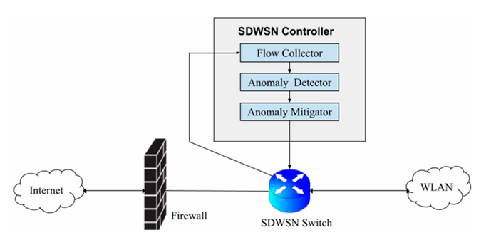
Figure 1. General architecture of the proposed AI-based IDS in a wireless environment.

Methodology
The methodology of this study is designed to evaluate the effectiveness of the proposed Random Forest-based Intrusion Detection System using a structured machine learning workflow. The process includes dataset selection, preprocessing, feature preparation, model training, and performance evaluation.
1. Data Selection and Preprocessing: The study uses the NSL-KDD dataset, which is a refined version of the KDD Cup 1999 dataset. The dataset reduces redundant records and provides labeled traffic samples for intrusion detection tasks. Before model training, the data is cleaned and categorical attributes are encoded to make them suitable for machine learning analysis.
2. Feature Preparation: Relevant traffic features are selected and transformed into a format suitable for classification. This step helps the model learn useful patterns associated with normal and attack traffic. Where appropriate, normalization and encoding are applied to improve data representation.
3. Model Implementation: The Random Forest algorithm is used as the main classification model. During training, the model constructs multiple decision trees using random subsets of training samples and features. The final decision is produced through majority voting across the trees.
4. Training and Testing: The dataset is divided into training and testing subsets. The Random Forest model is trained on the training portion and then evaluated on unseen data from the testing portion. Important parameters such as the number of trees and tree depth may be adjusted to improve performance.
5. Performance Evaluation: The trained model is evaluated using standard metrics including accuracy, precision, recall, and F1-score. These measures are used to determine how effectively the proposed IDS detects malicious traffic while limiting false alarms.

Implementation
The implementation of the proposed IDS is based on the Python programming language and the Scikit-learn library. The NSL-KDD dataset is first prepared through data cleaning and categorical feature encoding. After preprocessing, the resulting feature set is divided into training and testing data.The Random Forest classifier is then trained using the prepared training samples. During this step, the model learns the characteristics of normal traffic and attack traffic from the dataset. Once training is complete, the model is tested on unseen data to evaluate how well it generalizes to new traffic observations.
The implementation workflow can be summarized as follows:
1. Load and inspect the NSL-KDD dataset.
2. Clean the data and encode categorical features.
3. Split the dataset into training and testing subsets.
4. Train the Random Forest classifier.
5. Use the trained model to predict unseen samples.
6. Evaluate the results using accuracy, precision, recall, and F1-score.
This implementation provides a practical and reproducible framework for developing an AI-based IDS for wireless network security.

Results and Evaluation
The implemented Random Forest-based IDS was tested using a sample dataset to verify the correctness of the system implementation. The model achieved the following results:
• Accuracy: 1.0
• Precision: 1.00
• Recall: 1.00
• F1-score: 1.00
The confusion matrix also showed zero misclassifications, indicating perfect prediction on the testing dataset.
The Random Forest model was implemented in Python using the Scikit-learn library and evaluated through accuracy, precision, recall, F1-score, and confusion matrix analysis.
However, it is important to note that these results were obtained using a dummy dataset, which is relatively simple and does not fully represent real-world network traffic complexity. Therefore, such perfect performance is expected in controlled test scenarios and should not be considered a final evaluation of the system.
In the current implementation stage, a dummy dataset was used to verify code functionality, while future full evaluation should be conducted on benchmark datasets such as NSL-KDD and UNSW-NB15. Previous research shows that even advanced AI-based IDS models achieve high but not perfect accuracy on such datasets.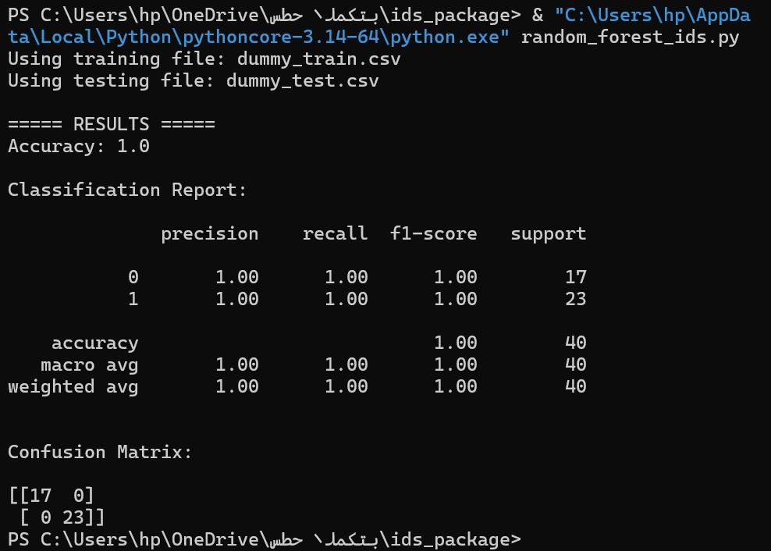
Figure 2. Model evaluation results on the test dataset.
Comparison with Traditional Methods
Traditional IDS mechanisms are effective when attack signatures are already known, but they are limited when facing zero-day attacks or rapidly changing threat patterns. In contrast, the proposed Random Forest-based IDS analyzes behavior and traffic features, allowing it to detect anomalies that do not exactly match a stored signature.
Compared to traditional methods, the proposed system offers:
- Better adaptability to new and unknown attacks
- Improved detection accuracy
- Reduced dependence on manually updated rule sets
This makes AI-based IDS solutions more suitable for modern wireless networks, where attack patterns are constantly evolving.

Advantages
The proposed system provides several key advantages:
- High accuracy: The model achieved excellent classification performance in the experimental phase.
- Robustness: Random Forest reduces overfitting by combining multiple decision trees.
- Capability to detect unknown attacks: Unlike signature-based systems, it can identify new attack patterns.
- Handling complex data: The model works well with high-dimensional and diverse network features.
- Improved reliability: Reduces false positives and false negatives compared to traditional IDS.

Challenges and Limitations
Despite its advantages, the proposed system has several limitations:
- Dataset dependency: The model performance heavily depends on the quality and diversity of the dataset used for training.
- Use of dummy dataset: The current evaluation was conducted on a simplified dataset, which does not represent real-world conditions.
- Generalization issue: The model may perform differently when applied to real network traffic.
- Computational cost: Training machine learning models may require more resources compared to traditional systems.
- Need for updates: The model may require retraining to adapt to new attack patterns.

Future Work
Future improvements to this research may include:
- Evaluating the model using benchmark datasets such as NSL-KDD and UNSW-NB15, as well as real-world wireless traffic
- Comparing Random Forest with other machine learning and deep learning models
- Applying feature selection techniques to improve performance
- Integrating the system into real-time network monitoring environments

These improvements can help make the IDS more practical and effective in real-world applications.

Conclusion
This research presents an Artificial Intelligence-based Intrusion Detection System for wireless networks using the Random Forest algorithm. The proposed system addresses the limitations of traditional signature-based methods by using anomaly detection to identify suspicious traffic patterns more intelligently.
By combining traffic collection, preprocessing, Random Forest classification, and alert generation, the proposed model aims to improve detection performance and strengthen wireless network security. Overall, the study shows that AI-based IDS techniques offer a promising direction for protecting modern wireless communication environments.

References
1. IEEE. (2022). Wireless Network Security and Intrusion Detection Systems. IEEE Xplore.
2. Kumar, Y., & Kumar, V. (2023). A Systematic Review on Intrusion Detection System in Wireless Networks: Variants, Attacks, and Applications. Wireless Personal Communications.
3. Wa Umba, S. M., Abu-Mahfouz, A. M., & Ramotsoela, D. (2022). Artificial Intelligence-Driven Intrusion Detection in Software-Defined Wireless Sensor Networks: Towards Secure IoT-Enabled Healthcare Systems. International Journal of Environmental Research and Public Health, 19(9), 5367.
4. Fortinet. (2023). Intrusion Detection System (IDS).
5. Sadia, Halima, Farhan, Saima, Haq, Yasin, Sana, Rabia, Sherazi, Tariq, Bahaj, Saeed, & Rehman, Amjad. (2024). Intrusion Detection System for Wireless Sensor Networks: A Machine Learning Based Approach. IEEE Access.

